Introduction
This project assignment presents an in-depth Exploratory Data Analysis (EDA) on a dataset correlating music listening habits with self-reported mental health metrics. Exploratory Data Analysis is a crucial initial step in any data science and machine learning pipeline. It involves the use of statistical graphics, summary statistics, and data visualization techniques to uncover underlying patterns, detect anomalies, test hypotheses, and check assumptions within the data.

Objective of the Project
The primary objective of this project is to conduct a comprehensive Exploratory Data Analysis (EDA) on the Music and Mental Health dataset to extract meaningful insights regarding how music consumption correlates with mental health status. To achieve this overarching goal, the project is divided into several specific, measurable objectives:
- Data Cleaning and Preprocessing: To systematically identify and handle missing values, correct data types, and normalize variables to ensure the integrity and quality of the dataset before analysis.
- Demographic Profiling: To analyze the demographic distribution of the respondents, understanding the spread of age, preferred streaming services, and active engagement with music (e.g., instrumentalists vs. non-instrumentalists).
- Univariate Analysis: To examine the isolated distributions of individual variables, such as the spread of self-reported scores (on a scale of 0 to 10) for Anxiety, Depression, Insomnia, and OCD.
- Bivariate and Multivariate Analysis: To investigate the complex relationships between multiple variables. This includes analyzing how different musical genres correlate with specific mental health conditions and determining if the total hours spent listening to music per day has a positive or negative correlation with mental health scores.
- Efficacy of Music Therapy: To evaluate the subjective impact of music on the respondents by analyzing the "Music effects" variable, determining what percentage of users feel music improves their condition versus those who feel it worsens it.
- Visual Storytelling: To utilize advanced data visualization techniques to present these statistical findings in an intuitive, accessible manner, facilitating better decision-making and easier interpretation of complex psychological data.

Tools & Technologies Used
To perform a robust and efficient Exploratory Data Analysis, a modern data science technology stack was utilized. The project relies heavily on the Python programming language and its rich ecosystem of data manipulation and visualization libraries. The specific tools and technologies employed in this project include:

1. Python
Python was chosen as the core programming language for this project due to its simplicity, readability, and unparalleled dominance in the field of data science. Its extensive community support and specialized libraries make it the ideal choice for handling complex datasets, performing statistical calculations, and generating visualizations.

2. Jupyter Notebook
The analysis was developed and executed within a Jupyter Notebook environment (`EDA_Project.ipynb`). Jupyter provides an interactive computational environment that allows for the seamless integration of executable code, formatted text (Markdown), mathematical equations, and visual plots in a single document. This interactive nature is critical for EDA, as it allows the analyst to iteratively query the data and immediately view the results.

3. Pandas
Pandas is a foundational Python library used for structured data operations and manipulation. In this project, Pandas was extensively utilized to load the dataset from a CSV file into a DataFrame, handle missing data (`dropna`, `fillna`), filter rows, aggregate data, and compute descriptive statistics (`describe`, `info`). It acts as the backbone for all data wrangling tasks.

4. NumPy
NumPy (Numerical Python) provides support for large, multi-dimensional arrays and matrices, along with a vast collection of high-level mathematical functions to operate on these arrays. It was used in conjunction with Pandas to handle complex numerical calculations and logical operations efficiently during the data transformation phases.

5. Matplotlib
Matplotlib is a comprehensive library for creating static, animated, and interactive visualizations in Python. It was used to construct the foundational plots for this project, such as bar charts, histograms, and scatter plots, allowing for granular control over the aesthetic elements of the graphs (titles, labels, and axes).

6. Seaborn
Built on top of Matplotlib, Seaborn provides a high-level interface for drawing highly attractive and informative statistical graphics. Seaborn was utilized to create complex visualizations with minimal code, such as correlation heatmaps, violin plots, and boxplots, which are essential for identifying outliers and understanding the density and distribution of the mental health scores across different music genres.

Project Description
The project revolves around the analysis of survey data collected to understand the correlation between a person's music taste and their self-reported mental health status. The dataset encapsulates a diverse set of variables ranging from basic demographics to granular musical preferences and psychological self-assessments.

1. Dataset Overview
The dataset consists of multiple records, where each row represents an individual respondent's survey answers. The data is multidimensional, capturing quantitative metrics (like hours listened per day) and qualitative metrics (like favorite genre and primary streaming service).

2. Key Features (Columns)
The dataset includes, but is not limited to, the following critical features:
- Age: The age of the respondent (Continuous).
- Primary streaming service: The platform the respondent primarily uses (e.g., Spotify, Apple Music, YouTube Music) (Categorical).
- Hours per day: The average number of hours the respondent spends listening to music daily (Continuous).
- While working: A boolean indicator of whether the respondent listens to music while working or studying (Categorical).
- Instrumentalist / Composer: Boolean indicators of whether the respondent actively plays an instrument or composes music, representing their level of active engagement with the medium (Categorical).
- Fav genre: The primary musical genre the respondent identifies as their favorite (Categorical).
- Exploratory: Indicates whether the respondent actively seeks out new music (Categorical).
- Mental Health Metrics: A set of four features—Anxiety, Depression, Insomnia, and OCD. Respondents rated their experience with these conditions on a scale from 0 (not at all) to 10 (extremely severe) (Ordinal/Continuous).
- Music effects: The respondent's subjective assessment of how music affects their mental health, categorized typically as 'Improve', 'No effect', or 'Worsen' (Categorical).

3. Scope of Analysis
The scope of this project is strictly observational. While the Exploratory Data Analysis will highlight strong correlations and trends (e.g., individuals who listen to Classical music might report lower Insomnia scores), it is important to note that correlation does not imply causation. The project aims to map the data landscape, identify anomalies, and present a statistical narrative rather than diagnosing psychological conditions or prescribing musical therapies. The insights generated serve as a foundation for further, more rigorous statistical hypothesis testing or machine learning predictive modeling.

7. Implementation / Working
The implementation of the project followed a structured, chronological data science methodology. The steps were executed sequentially within the Jupyter Notebook to transform raw data into actionable visual insights.

Step 1: Environment Setup and Data Loading
The process began by importing the necessary libraries: pandas for data manipulation, numpy for numerical operations, and matplotlib.pyplot and seaborn for visualization. The dataset was then ingested using the pd.read_csv() function, creating the primary DataFrame. The head() function was immediately invoked to visually inspect the first few rows of the data, ensuring the import was successful and the columns were aligned correctly.

Step 2: Data Profiling and Cleaning
Before any analysis could occur, the structural integrity of the data had to be verified. The df.info() and df.describe() methods were used to understand the data types, row counts, and basic statistical summaries (mean, standard deviation, min, max) of the numerical columns.
Data cleaning involved checking for missing or null values using df.isnull().sum(). Depending on the volume and significance of the missing data, rows containing critical null values (such as missing mental health scores) were dropped using dropna(), while non-critical missing categorical values were either imputed or categorized as 'Unknown' to preserve the integrity of the remaining data in those rows. Age outliers (e.g., biologically impossible ages entered by respondents) were identified via boxplots and filtered out to prevent analytical skew.

Step 3: Univariate Analysis
The analysis began by examining single variables. Histograms and kernel density estimate (KDE) plots were generated using Seaborn to visualize the distribution of Age and the four mental health metrics (Anxiety, Depression, Insomnia, OCD). This step revealed the general psychological baseline of the survey respondents, highlighting whether the sample leaned towards high or low severity in these conditions. Bar charts were plotted to count the frequency of Categorical variables, revealing the most popular streaming services and favorite genres.

Step 4: Bivariate Analysis
Moving beyond single variables, the implementation explored the relationships between two variables. Boxplots and Violin plots were extensively used to map Categorical data against Continuous data. For instance, 'Fav genre' was plotted on the X-axis against 'Depression' on the Y-axis. This visually demonstrated the median scores and the interquartile ranges of depression for each distinct musical genre, highlighting potential correlations.
Scatter plots were generated to assess the relationship between 'Hours per day' (listening to music) and specific mental health scores, looking for linear or non-linear trends that might suggest excessive listening is a coping mechanism for severe anxiety or depression.

Step 5: Multivariate Analysis and Correlation
To understand the broader interdependencies of all numerical variables simultaneously, a correlation matrix was computed using the Pearson correlation coefficient. This matrix was then visualized using a Seaborn heatmap (sns.heatmap()), annotated with correlation values. This step was crucial for identifying strong positive or negative correlations (e.g., determining if high Anxiety scores are strongly positively correlated with high Depression scores within this specific dataset).

Results
The Exploratory Data Analysis yielded several profound insights regarding the demographic distribution of the survey respondents and the intricate connections between their music consumption habits and mental health statuses. The key findings are summarized below:

1. Demographic and Behavioral Trends
- Age Distribution: The majority of the respondents fall within the young adult demographic (ages 16 to 25). This indicates that the findings are heavily representative of Gen Z and younger Millennials, a demographic historically shown to have high engagement with digital streaming platforms.
- Streaming Platform Dominance: Spotify emerged as the overwhelmingly dominant primary streaming service, dwarfing competitors like Apple Music and YouTube Music.
- Listening Habits: A significant portion of the user base reports listening to music while working or studying, suggesting that music is primarily utilized as a background utility for focus and productivity rather than just isolated entertainment.

2. Music Genres and Mental Health Correlations
- Genre Variability: Genres such as Rock, Pop, and Metal were among the most frequently cited favorite genres.
- Anxiety and Depression by Genre: The boxplot visualizations revealed variations in median mental health scores across genres. Listeners whose favorite genres were Metal or Rock often showed slightly wider interquartile ranges in self-reported Anxiety and Depression scores compared to listeners of Classical or Jazz music, though outliers existed in all categories.
- Insomnia and Lo-Fi/Classical: Bivariate analysis indicated a trend where listeners of ambient, Lo-Fi, or Classical music reported varied levels of insomnia, with many qualitative responses suggesting these genres are used specifically as sleep aids.

3. The Efficacy of Music as a Coping Mechanism
- Perceived Effect: When analyzing the 'Music effects' categorical variable, a vast majority of respondents reported that music "Improves" their mental health condition. Only a minuscule fraction reported that it "Worsens" their state.
- Hours Listened vs. Severity: Scatter plots mapping 'Hours per day' against condition severity showed a slight positive density in higher hours for individuals with higher Anxiety or Depression scores. This suggests a behavioral pattern where individuals experiencing higher psychological distress may use music more frequently as an emotional coping mechanism or escapism.

4. Metric Inter-correlations
The correlation heatmap revealed a notable positive correlation between Anxiety and Depression scores. Individuals reporting high levels of Anxiety were statistically more likely to report higher levels of Depression, which aligns with established psychological literature regarding the co-occurrence of these conditions. Insomnia also showed moderate positive correlations with both Anxiety and Depression.

Conclusion
This project successfully executed a comprehensive Exploratory Data Analysis on the Music and Mental Health dataset, transitioning raw survey data into structured, visual, and actionable insights. Through rigorous data cleaning, univariate profiling, and complex bivariate/multivariate visualizations, the project achieved its objective of mapping the relationship between auditory habits and psychological well-being.
The findings emphasize that music is a deeply ingrained coping mechanism for the younger demographic, with a vast majority of users reporting that music actively improves their mental health state. While certain correlations were observed—such as slight variations in mental health baseline scores across different musical genres, and higher listening hours among those with elevated anxiety or depression—the data predominantly highlights music as a therapeutic tool rather than a negative catalyst.

References
- Dataset Source: Kaggle. "Music and Mental Health Survey Results." Available online at kaggle.com. (Accessed during project implementation).
- Pandas Documentation: The pandas development team. "pandas-dev/pandas: Pandas." Zenodo, 2023. Available at: https://pandas.pydata.org/docs/
- Seaborn Documentation: Waskom, M., et al. "Seaborn: statistical data visualization." Python library documentation. Available at: https://seaborn.pydata.org/
- Matplotlib Documentation: Hunter, J. D. "Matplotlib: A 2D graphics environment." Computing in Science & Engineering, vol. 9, no. 3, pp. 90-95, 2007. Available at: https://matplotlib.org/stable/contents.html
- Python Software Foundation: "Python Language Reference, version 3.x." Available at: https://www.python.org/

Output Screenshots

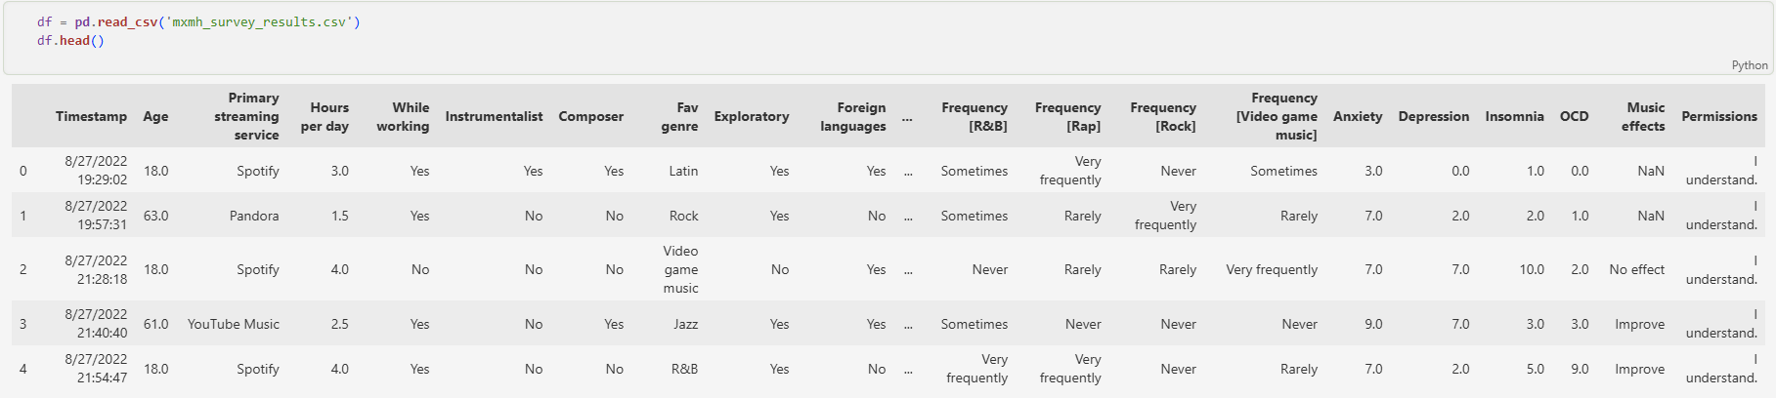
1. Data Loading and Head Preview

2. Data Cleaning - Null Value Check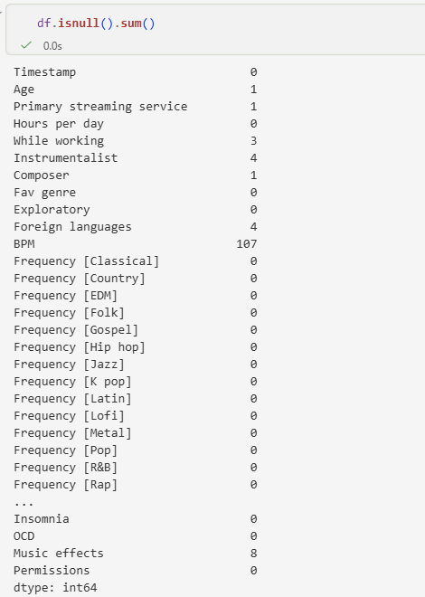

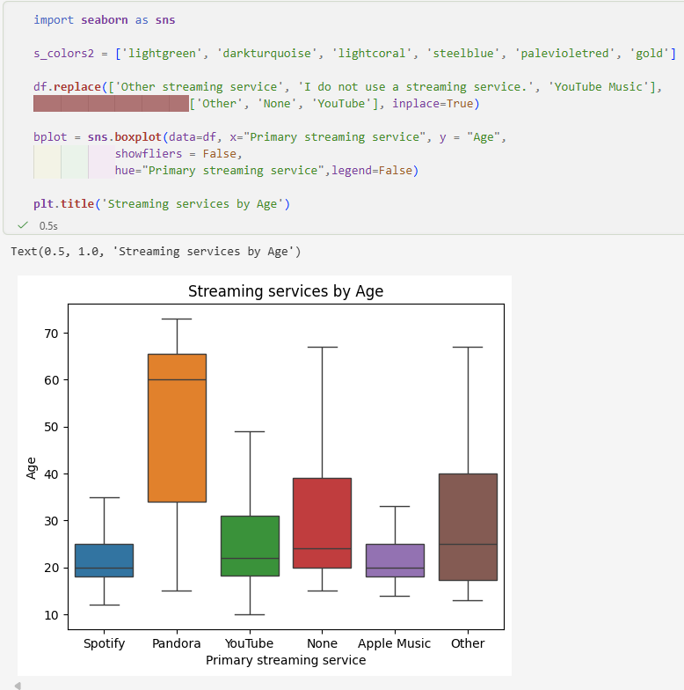
3. Age Distribution Analysis

4. Visualizing Music Effects
